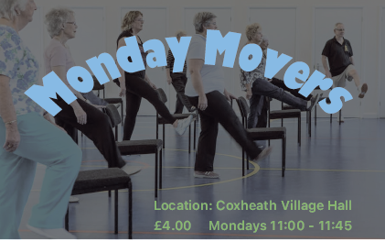

**Monday Movers** is an exercise class for retired ladies and

gentlemen over the age of 50. Our main focus is bringing you

an enjoyable way to exercise, keeping to movements within

your ability and providing chairs for those who need them.

Each session shall leave you feeling good, having improved

the muscles that you use everyday and reminding you of ones

that you had long forgotten. With nostalgic tunes and a friendly

crowd, Monday Movers is a social way to start off your week

and alleviate those aches and pains that are a part of daily life.

Why not give us a try and see for yourself

For more information, reach out to **Barbara** at **01622 296863**

and book your place.